ANALYSING ARGUMENT

TEACHER:

STUDENT NAME: ____________________________

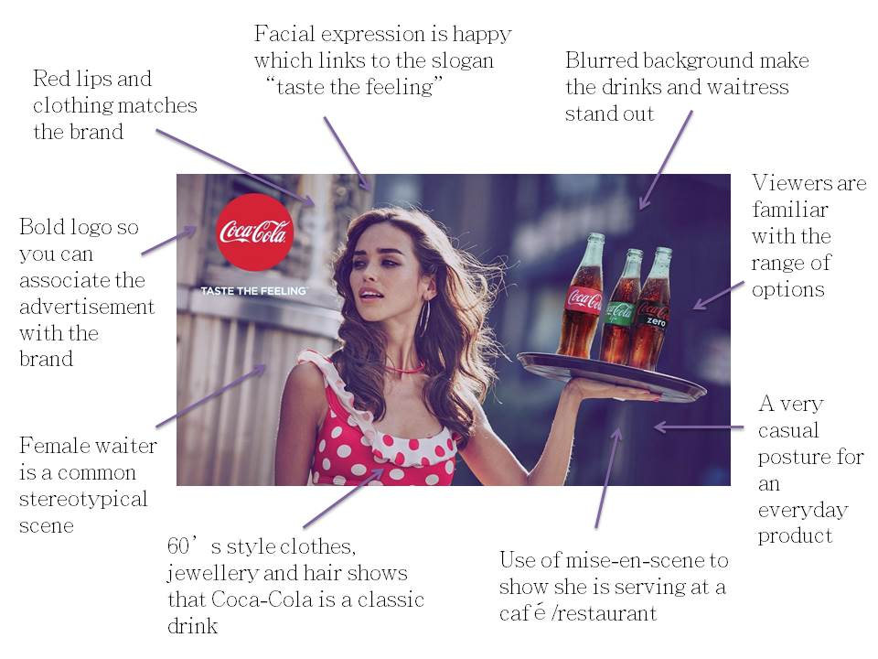

Contents

LI: Understand exactly how pervasive advertising is in my own life 3
LI: Understand the terms Contention and Intention and apply them to advertising examples 4
LI: Develop knowledge about Anti-Bullying Advertising, and apply understanding of contention and intention 6
LI: To become familiar with persuasive language techniques 9
LI: To become familiar with persuasive visual techniques 11
LI: Know the persuasive elements and use these to analyse print ads and write an analytical paragraph 13
LI: To identify and annotate written and visual persuasive techniques used 16
LI: To complete a common formative assessment analysing two anti bullying advertisements and write a analysis essay 22
LI: To complete assessment task analysing anti-bullying advertisements and writing an analysis essay 26

LI: Understand exactly how pervasive advertising is in my own life
APK: What is advertising? What are some examples of advertising that you have seen in the past week?
Activity: Complete the survey below to examine how pervasive advertising is in your life.

Advertising Survey
1. You will find advertising in the following places:
On the side of product  TV  Radio  Taxis  Buses  Bus shelters  Billboards  Google  Email  Shops | Most internet sites  Facebook  Instagram  YouTube  TV  Newspapers  Magazines  Books  Movies  On many clothes
Think about where you have been in the last 24 hours. List the places or moments which have been totally free from advertising:
2. Which advertising medium do you think is the most effective – rank in order:
- TV
- Radio
- Internet
- Magazine/Newspaper
- Billboards
- Ads on taxis/buses
- Logos
3. Which purchases of the following products have been influenced by advertising you have seen:
- Fast food
- Soft drinks
- Clothes
- iPhones
- Computers
- Music
- Beauty products
- Deodorant
4. How many minutes of advertising per week would you be exposed to?
Medium | Exposure | Hours spent in a typical week |  | Minutes of advertising I am exposed to:
TV | 13 minutes per hour
Google | Every minute you look at search results on Google
FB | Every minute you are on a Facebook profile
Instagram | Every minute you are scrolling through Instagram
YouTube | Every minute you watch a YouTube video
Movies | 5 minutes of product placement in every hour
Total minutes exposed to advertising for the week
5. Which of the following products do you think should not be advertised?
- Cigarettes
- ‘Alco-pops’ aimed at teenagers
- Junk food aimed at children
- Soft drink
Reflection: Two reasons this is a bad thing, and two reasons it could be a good thing.
Paste this into your English notebook.

LI: Understand the terms Contention and Intention and apply them to advertising examples
Contention Definition: A confident and forceful statement of fact or belief, especially one maintained in an argument. In advertising, we can think of this as the message.
Intended Effect: The intended effect the text is meant to have. Think F.A.T: Feel, Act, Think
The intention is to make the audience feel…
The intention is to make the audience (act)…
The intention is to make the audience think…
Match the Contention with the Correct Advertisement
- You get better value for money when you buy this
- This will keep everyone in the family happy
- Having this will make you happy
- This is so good, you won’t want to share it

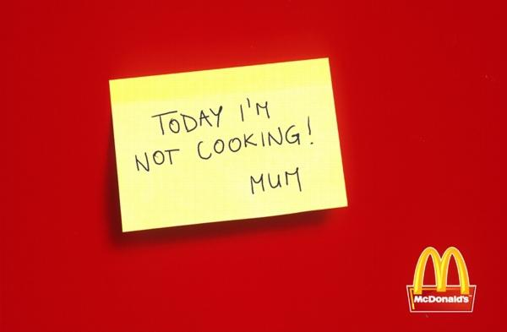 |  | 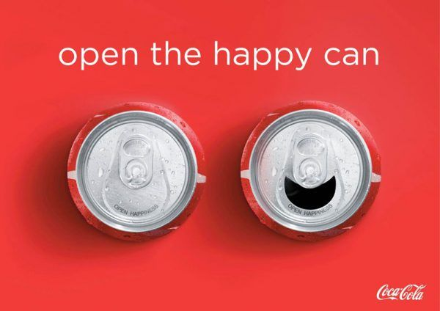
The contention of this ad is:  _______________________________________  The intention is to make the audience feel  _______________________________________  The intention is to make the audience (act)  _______________________________________  The intention is to make the audience think  _______________________________________ | The contention of this ad is:  _______________________________________  The intention is to make the audience feel  _______________________________________  The intention is to make the audience (act)  _______________________________________  The intention is to make the audience think  _______________________________________

Paste this into your English notebook.

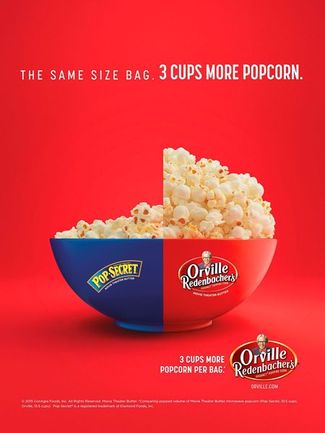 |  | 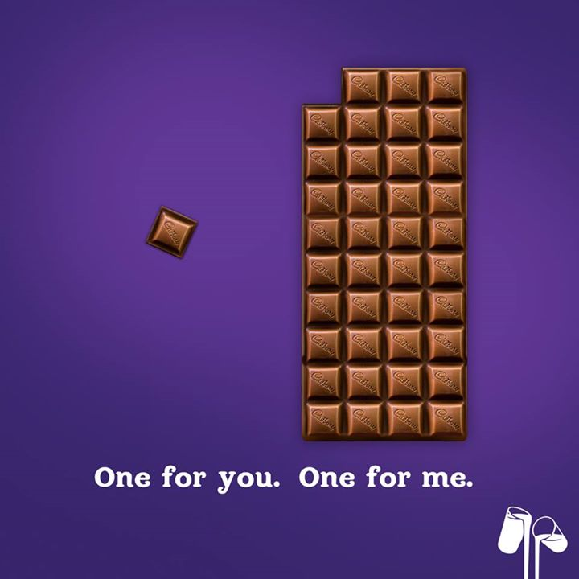
The contention of this ad is:  _____________________________________  The intention is to make the audience feel  _____________________________________  The intention is to make the audience (act)  _____________________________________  The intention is to make the audience think  _____________________________________ |  | The contention of this ad is:  _______________________________________  The intention is to make the audience feel  _______________________________________  The intention is to make the audience (act)  _______________________________________  The intention is to make the audience think  _______________________________________
Reflection | The contention of this ad is:  _______________________________________  The intention is to make the audience feel  _______________________________________  The intention is to make the audience (act)  _______________________________________  The intention is to make the audience think  _______________________________________
Paste this into your English notebook

LI: Develop knowledge about Anti-Bullying Advertising, and apply understanding of contention and intention
Public Health Advertising
Public health advertising is often designed to alarm viewers, so when we consider the intention of Public Health Advertising, these words will help
Afraid  Shocked  Alarmed  Horrified | Worried  Scared  Disgusted  Terrified | Guilty  Ashamed  Responsible  Concerned  Disturbed
Bullying is not just ‘playing around’ or harmless fun. Bullying happens when someone has (or thinks they have) more power than someone else. This could be
- power in numbers
- being older or stronger
- popularity
- being in the majority.
There are many forms of bullying including:
- verbal (e.g. putting someone down or threatening to cause harm)
- physical (e.g. contact that hurts someone or breaks their things)
- social (e.g. spreading rumours, excluding someone, embarrassing someone in public)
- cyberbullying (e.g. sending harmful messages, pictures or making comments on social networking sites, like Facebook, Instagram or Snapchat). This type of bullying can be anonymous and posted online where it can be seen by lots of people. And it can go on 24 hours a day, 7 days a week, so people don’t get a rest from it.
Bullying can also be done secretly, like doing or saying something behind someone’s back. This type of bullying can be harder to see, but it’s no less damaging.
Unfortunately bullying is common. Almost a quarter of young people aged 14-25 reported being bullied in the previous 12 months.
Task: Imagine you meet someone who has never heard of bullying and doesn’t understand why it might be a problem.
In groups, you must read the fact sheets, and come up with an explanation for this person to inform them. You must show them: What bullying is? Why it’s a problem? A visual representation of the problem

Paste this into your English notebook.
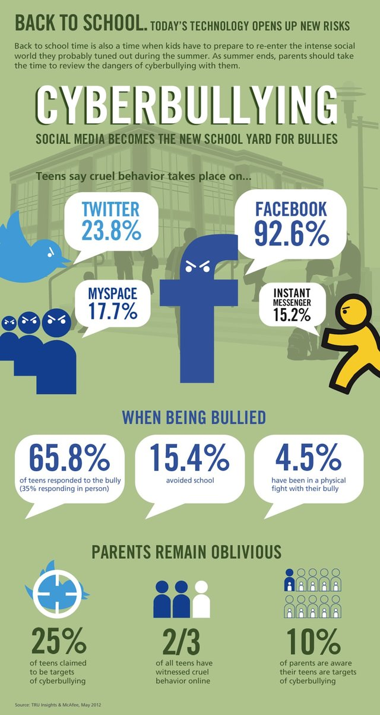
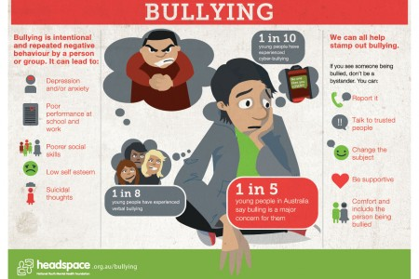
Paste this into your English notebook.

The contention of this ad is:

_______________________________________

The intention is to make the audience feel
_______________________________________
The intention is to make the audience (act)
_______________________________________
The intention is to make the audience think
_______________________________________

Reflection:
Contention
The advertisement is arguing that___________________________________________________________________
Intention
and wants the audience to think about________________________________________________________

Paste this into your red notebook.

LI: To become familiar with persuasive language techniques
Advertisements are carefully constructed for a specific purpose.
This purpose is the intention: How the creator wants the audience to feel, act, and think.
This means that every element of an advertisement has been especially chosen and put there for a reason.
This includes visual and written persuasive techniques.
Persuasive Language Technique | Definition | Example | Effect
Inclusive Pronouns | First-person plural pronouns to evoke a sense of commonality | We must work together to save our planet. | Aims to make the audience feel included in the issue and take the creator’s side.
Direct Address | When the text talks directly to the audience, often using ‘you’ or a term for the collective. | You can make a difference. | Talking directly to the audience pushes them to see it as relevant.
Imperative Verbs | Action words that give a command. | Stop pollution  Act now  Do something  Make the pledge | These are used to order the audience to do something and take action.
Emotive Language | Words and phrases meant to evoke an emotional response | These innocent animals are starving to death on full stomachs.  Coke is choking our oceans. | This is used to make the audience feel particular emotions, which involves them in the issue.
Declarative Statement | A statement that declares a fact. The opposite of a question. | When we pollute the sea, we pollute for a long time. | These offer information in a way that is difficult for the audience to argue with.
Statistics | Numerical data that is used to prove a point. | A recent study showed that 35% of the fish from the ocean have ingested plastic. | These are persuasive because they often show the impact of an issue using researched data.
Facts or Evidence | Scientific facts or research – information that is true | - Plastic breaks down into such small segments that pieces of one bottle could end up on every mile of beach throughout the world | These show that the creator has researched the issue and found scientific information to back up their point, which encourages the audience’s trust.
Alliteration | The occurrence of the same letter or sound at the beginning of adjacent or closely connected words | Please stop Plastic Pollution  Ban the Bag | This is used sometimes to make the message catchy or memorable.
Punctuation | Especially exclamation marks, question marks, dashes, and ellipses are used for persuasive effects | Don’t load the planet with what doesn’t belong to it! | These are used to make the reader ‘hear’ the tone of the writing, which makes it more urgent.
Paste this into your English notebook.

 | STICKS AND STONES MAY BREAK MY BONES, BUT WORDS WILL NEVER HURT ME.  The nursery rhyme above is not so true anymore. Today, words are like bullets. It only takes one word to destroy the way someone thinks or acts everyday.  Let’s stop bullying together | 1. Which of the Persuasive Language Techniques in your table has this advertisement used?  ______________________________  2. What is the intention of one?  ______________________________
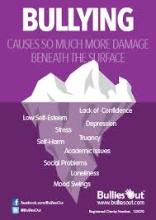 | Bullying causes so much more damage beneath the surface | 1. Which of the Persuasive Language Techniques in your table has this advertisement used?  ______________________________  2. What is the intention of one?  ______________________________
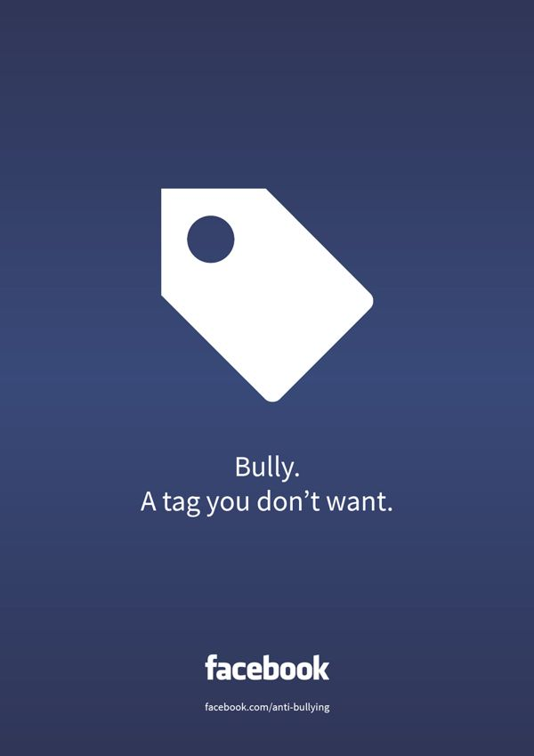 | Bully. A tag you don’t want. | 1. Which of the Persuasive Language Techniques in your table has this advertisement used?  ______________________________  2. What is the intention of one?  ______________________________
Reflection:
The advertisement by _____ has used the persuasive language technique of ___________ with the words “______”. The intention of this technique is to ______________________________________________
Paste this into your English notebook.

LI: To become familiar with persuasive visual techniques
 | EVERY YEAR, 8 MILLION TONS OF WASTE ARE DISCHARGED INTO THE OCEAN.  IT’S TIME TO STOP!  Surfrider Foundation | Task: Which techniques from yesterday’s lesson can you identify in this ad?
Colours have associated meanings which we often carry without even being aware of them.
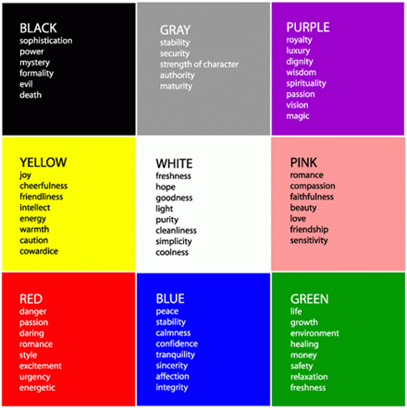
Remembering that ad creators make all their decisions intentionally, if you were talking to the creator, what questions could you ask them about this ad?
Why is it trapped in a bottle?
What is it holding in its claw?
Why is it stuck in a bottle?
Why have they included this fact? (EVERY YEAR, 8 MILLION TONS OF WASTE ARE DISCHARGED INTO THE OCEAN.)
Why have they chosen a crab and not another animal?

Paste this into your English notebook.
Symbolism is the use of symbols to represent ideas or qualities.

Task: What is the symbol in this image?
What is it supposed to remind us of?
Why has the creator used it?

Questions we can ask about the arrangement or composition of this ad:
- Why did the creator choose to use a close-up of the crab’s face?
- Why did the creator leave so much blank space around the focus image?
- Why is the text so small?

Composition-This refers to the arrangement or placement of visual elements in a particular image

Reflection
 | When we pollute the earth we pollute the ocean | Task: What questions could you ask about this ad?  CHALLENGE: Attempt to answer the questions you have posed.  Remember:  Use of colour  Symbolism  Composition  Language techniques
Paste this into your English notebook.

LI: Know the persuasive elements and use these to analyse print ads and write an analytical paragraph

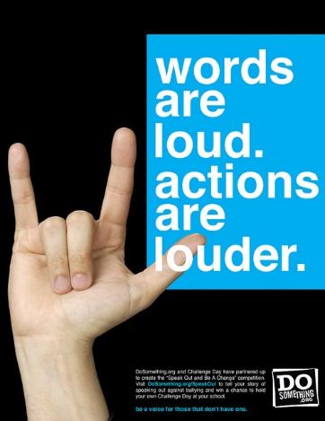  Text: Be a voice for those that don’t have one. | 1. At a glance, what is the symbolism of the hand gesture?  _________________________________________  2. What is the written text forcing us to realise? How does this make us feel?  _________________________________________  3. What colours are used and why are they effective?  _________________________________________  4. What action about anti bullying does Do Something.org want you to think about specifically?  _________________________________________  5. What is the contention of this ad?  _________________________________________  6. What is the intention?  _________________________________________
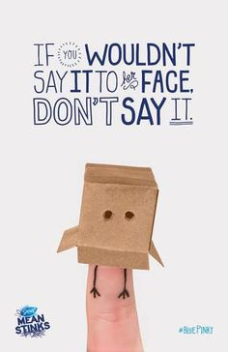 | 1. When you first see this picture, what does it look like?  _________________________________________  2. What is not quite right about the image?  _________________________________________  3. What is the written text forcing us to realise? How does this make us feel?  _________________________________________  4. What colours are used and why are they effective?  _________________________________________  5. What fact about bullying does Blue Pinky want you to think about specifically?  _________________________________________  6. What is the contention of this ad?  _________________________________________  7. What is the intention?  _________________________________________
Paste this into your English notebook.

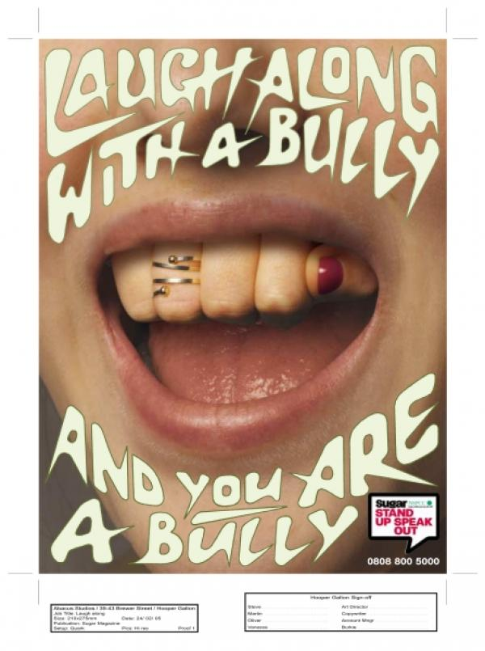 | 1. When you first see this picture, what does it look like?  _________________________________________  2. What is not quite right about the image?  _________________________________________  3. What is the written text forcing us to realise? How does this make us feel?  _________________________________________  4. What colours are used and why are they effective?  _________________________________________  5. What fact about bullying does Stand up and Speak Out want you to think about specifically?  _________________________________________  6. What is the contention of this ad?  _________________________________________  7. What is the intention?  _________________________________________
Text: words can kill. Say no to discrimination. We are all the same. | 1. When you first see this picture, what does it look like?  _________________________________________  2. What is not quite right about the image?  _________________________________________  3. What is the written text forcing us to realise? How does this make us feel?  _________________________________________  4. What colours are used and why are they effective?  _________________________________________  5. What fact about bullying does Blue Pinky want you to think about specifically?  _________________________________________  6. What is the contention of this ad?  _________________________________________  7. What is the intention?  _________________________________________
Paste this into your English notebook.

Reflection
Using these sentence starters, choose one of the four ads you have written notes for, and complete a paragraph analysing this ad. Re-write this paragraph into your red notebook.
At first glance, this ad appears to show______________________________________________________________.
However, it is clear something is wrong because_______________________________________________________.
The written text says ‘_____________________________________________________________________________’
This forces the audience to realise________________________________________ which makes them feel________
The colours __________________________________________________ are effective because_________________
The creator of the ad wants its audience to know that anti bullying________________________________________.
Therefore, the contention of this ad is________________________________________________________________.
And the intention is______________________________________________________________________________.
Paste this into your red notebook.

LI: To identify and annotate written and visual persuasive techniques used
Annotate the ad for persuasive language techniques
Annotate the ad for persuasive visual techniques
What is the effect on the audience of each technique?
What is the contention of the ad?

Paste this into your red notebook.

Fill out the table analysing each aspect of this ad.

WHAT is the message?  (What is the Contention?) | HOW have they presented it?  (Visual and Language choices) | WHY have they done it this way?  (What is the Intention?)
 | What is the first visual technique the creator has used and describe it? | Explain the effect of this visual element on the audience
 | What is the second visual technique the creator has used and describe it? | Explain the effect of this visual element on the audience
 | What is the language techniques the creator has used and write the quote? | Explain what effect each language technique is meant to have on the audience

Paste this into your red notebook.

Write out the analysis using the following sentence starters.
What is the message?  How is it shown?  Why is it shown this way? | The message of the advertisement is…………………………………………………………………………  ………………………………………………………………………………………………………………………………...  …………………………………………………………………………………………………………………………………  The first visual technique the creator has used is……………………………………………………….  ………………………………………………………………………………………………………………………………...  …………………………………………………………………………………………………………………………………  The effect of this visual element on the audience is to ……………………………………………  ………………………………………………………………………………………………………………………………...  The second visual technique the creator has used is………………………………………………..  ………………………………………………………………………………………………………………………………...  …………………………………………………………………………………………………………………………………  The effect of this visual element on the audience is to  …………………………………………………………………………………………………………………………………  ………………………………………………………………………………………………………………………………...  A persuasive language technique used in the line “…………………………………………………..”  is an example of……………………………………………………………………………………………………….  …………………………………………………………………………………………………………………………………  ………………………………………………………………………………………………………………………………...  The effect of this language technique on the audience is to…………………………………….  …………………………………………………………………………………………………………………………………

Paste this into your red notebook.

Annotate the ad for persuasive language techniques
Annotate the ad for persuasive visual techniques
What is the effect on the audience of each technique?
What is the contention of the ad?

\

Paste this into your red notebook.

Fill out the table analysing each aspect of this ad.

WHAT is the message?  (What is the Contention?) | HOW have they presented it?  (Visual and Language choices) | WHY have they done it this way?  (What is the Intention?)
 | What is the first visual technique the creator has used and describe it? | Explain the effect of this visual element on the audience
 | What is the second visual technique the creator has used and describe it? | Explain the effect of this visual element on the audience
 | What is the language techniques the creator has used and write the quote? | Explain what effect each language technique is meant to have on the audience

Paste this into your red notebook.

Write out the analysis using the following sentence starters.

What is the message?  How is it shown?  Why is it shown this way? | The message of the advertisement is…………………………………………………………………………  ………………………………………………………………………………………………………………………………...  …………………………………………………………………………………………………………………………………  The first visual technique the creator has used is……………………………………………………….  ………………………………………………………………………………………………………………………………...  …………………………………………………………………………………………………………………………………  The effect of this visual element on the audience is to ……………………………………………  ………………………………………………………………………………………………………………………………...  The second visual technique the creator has used is………………………………………………..  ………………………………………………………………………………………………………………………………...  …………………………………………………………………………………………………………………………………  The effect of this visual element on the audience is to  …………………………………………………………………………………………………………………………………  ………………………………………………………………………………………………………………………………...  A persuasive language technique used in the line “…………………………………………………..”  is an example of……………………………………………………………………………………………………….  …………………………………………………………………………………………………………………………………  ………………………………………………………………………………………………………………………………...  The effect of this language technique on the audience is to…………………………………….  …………………………………………………………………………………………………………………………………

Paste this into your red notebook.

LI: To complete a common formative assessment analysing two anti bullying advertisements and write a analysis essay

Year Level: |  |  | Subject: | CFT Title:
Completion Date:
Mark: | 20 | = % |  | Grade:
Brief Description of the Task:
You need to analyse and annotate the following advertisement.
You need to complete the graphic organiser to demonstrate your understanding of how the advertisement below attempts to portray a message and affect the audience.

CRITERIA | Not shown  0 | Very low  1 | Low  2 | Medium  3 | High  4 | Very high  5
Demonstrates a strong understanding of the text, including an accurate interpretation of the contention.
Identifies the persuasive features of the advertisement that support the contention and intention.
Articulates the intention (the intended effect) with accuracy and sophistication
Expression, including spelling, grammar, and effective punctuation

Common Formative Task-Analysing Advertisement
Advertisement 1:
Advertisement 2

WHAT is the message?  (What is the Contention?) | HOW have they presented it?  (Visual and Language choices) | WHY have they done it this way?  (What is the Intention?)
Advertisement 1
Advertisement 2

The message of the advertisement is…………………………………………………………………………………………………………
………………………………………………………………………………………………………………………………......................................
……………………………………………………………………………………………………………………………….....................................
The first visual technique the creator has used is…………………………………………………………………………………….
……………………………………………………………………………………………………………………………….....................................
The effect of this visual element on the audience is to ………………………………………………………………..……………
……………………………………………………………………………………………………………………………….....................................
……………………………………………………………………………………………………………………………….....................................
The second visual technique the creator has used is…………………………………………………………………………..……..
……………………………………………………………………………………………………………………………….....................................
The effect of this visual element on the audience is to
……………………………………………………………………………………………………………………………….....................................
……………………………………………………………………………………………………………………………….....................................
A persuasive language technique used in the line “……………………………………………………………………….…………..
……………………………………………………………………………………………………………………………………………………….…………”
is an example of………………………………………………………………………………………………………………………………………….
The effect of this language technique on the audience is to………………………………………………………………………
……………………………………………………………………………………………………………………………….....................................
…………………………………………………………………………………………………………………………………………………………………..
A second persuasive language technique used in the line “………………………………………………………………………..
………………………………………………………………………………………………………………………………………………………..………”
is an example of………………………………………………………………………………………………………………………………………..
The effect of this language technique on the audience is to……………………………………………………………………….
……………………………………………………………………………………………………………………………….....................................
……………………………………………………………………………………………………………………………….....................................

LI: To complete assessment task analysing anti-bullying advertisements and writing an analysis essay

Year Level: |  |  | Subject: | AT Title:
Completion Date:
Mark: | 25 | = % |  | Grade:
Brief Description of the Task:
You need to write two analytical paragraphs. One analysing the Anti-Plastic Ad, and one analysing the Road Safety ad. Remember to include the contention and the intention, as well as pointing to specific persuasive features of the ad.
CRITERIA | Not shown  0 | Very low  1 | Low  2 | Medium  3 | High  4 | Very high  5
Demonstrates a strong understanding of the text, including an accurate interpretation of the contention.
Identifies the persuasive features of the advertisement that support the contention and intention.
Articulates the intention (the intended effect) with accuracy and sophistication
Clear and effective structuring of paragraphs.
Expression, including spelling, grammar, and effective punctuation

Feedback:
…………………………………………………………………………………………………………………………….....
…………………………………………………………………………………………………………………………….....
…………………………………………………………………………………………………………………………….....

Assessment Task-Analysing Advertisement
Advertisement 1

Advertisement 2

WHAT is the message?  (What is the Contention?) | HOW have they presented it?  (Visual and Language choices) | WHY have they done it this way?  (What is the Intention?)
Advertisement 1
Advertisement 2

The message of the advertisement is…………………………………………………………………………………………………………
………………………………………………………………………………………………………………………………......................................
……………………………………………………………………………………………………………………………….....................................
The first visual technique the creator has used is…………………………………………………………………………………….
……………………………………………………………………………………………………………………………….....................................
The effect of this visual element on the audience is to ………………………………………………………………..……………
……………………………………………………………………………………………………………………………….....................................
……………………………………………………………………………………………………………………………….....................................
The second visual technique the creator has used is…………………………………………………………………………..……..
……………………………………………………………………………………………………………………………….....................................
The effect of this visual element on the audience is to
……………………………………………………………………………………………………………………………….....................................
……………………………………………………………………………………………………………………………….....................................
A persuasive language technique used in the line “……………………………………………………………………….…………..
……………………………………………………………………………………………………………………………………………………….…………”
is an example of………………………………………………………………………………………………………………………………………….
The effect of this language technique on the audience is to………………………………………………………………………
……………………………………………………………………………………………………………………………….....................................
…………………………………………………………………………………………………………………………………………………………………..
A second persuasive language technique used in the line “………………………………………………………………………..
………………………………………………………………………………………………………………………………………………………..………”
is an example of………………………………………………………………………………………………………………………………………..
The effect of this language technique on the audience is to……………………………………………………………………….
……………………………………………………………………………………………………………………………….....................................
……………………………………………………………………………………………………………………………….....................................

